Reactor cell for operando spectroscopy/diffraction of solid catalysts in gas and liquid phase environments
Thibault Fovanna, Rob J.G. Nuguid, Oliver Kröcher, Maarten Nachtegaal, Davide Ferri, Paul Scherrer Institut, Villigen, Switzerland; Thibault Fovanna, Rob J.G. Nuguid, Oliver Kröcher, École polytechnique fédérale de Lausanne (EPFL), Lausanne, Switzerland

Spectroscopy and diffraction methods are essential tools of the operando methodology. Yet every analytical technique imposes limitations for the sample environment that make often difficult to compare measurements with the same sample but with different physico-chemical method. Combination of two or more techniques, e.g. infrared spectroscopy (IR) and X-ray absorption spectroscopy (XAS), in one experiment is a powerful tool to analyze solid catalysts at work from various material perspectives. Several studies have demonstrated reactor cells capable of coupling two or more radiations and measuring the same portion of catalyst. In the case of the mentioned combination of IR and XAS and of gas environment, typically the design of commercial diffuse reflectance (DRIFTS) cells is the starting point of the cell modification to enable transmission of X-rays. In this case, the cells are optimized for DRIFTS but often exhibit unsatisfactory fluid dynamic behavior or temperature control.
In this work, we describe the design of a cell for combined infrared spectroscopy and X-ray methods that is inspired from that of transmission XAS cells [1]. The IR radiation is coupled in diffuse reflectance mode. However, the sample is in contact with the IR transparent window, which is a wall of the cell, and the gas is forced to pass through the sample in principle as in a lab scale plug flow reactor for catalytic activity measurements.
We demonstrate that the cell can be considered a catalytic reactor for gas phase reactions using CO oxidation and the determination of the activation energy of the reaction [2]. This cell has been used to measure DRIFTS, quickXAS [1], high energy XRD [2], and X-ray emission spectroscopy (XES) [3]. In principle, simultaneous DRIFTS-quickXAS measurements can be carried out, but the aim of this work is to demonstrate the use of a cell together with a setup including a mass spectrometer (MS) to enable repetition of the same experiment with the various physico-chemical methods. Unpublished Raman, pair distribution function (PDF) and small angle X-ray scattering (SXAS) measurements are available.
The same cell can be used for experiments with liquid environment at slightly elevated pressure (10 bar) and was tested for reduction of PdO/Al₂O₃ using XAS and high energy XRD. In this case, the residence time distribution (RTD) properties have also been determined using pulses of toluene in cyclohexane to describe the cell as an ideal reactor. For operando experiments, the cell can be interfaced to a FTIR spectrometer or a NMR spectrometer for online monitoring or to a GC/HPLC.
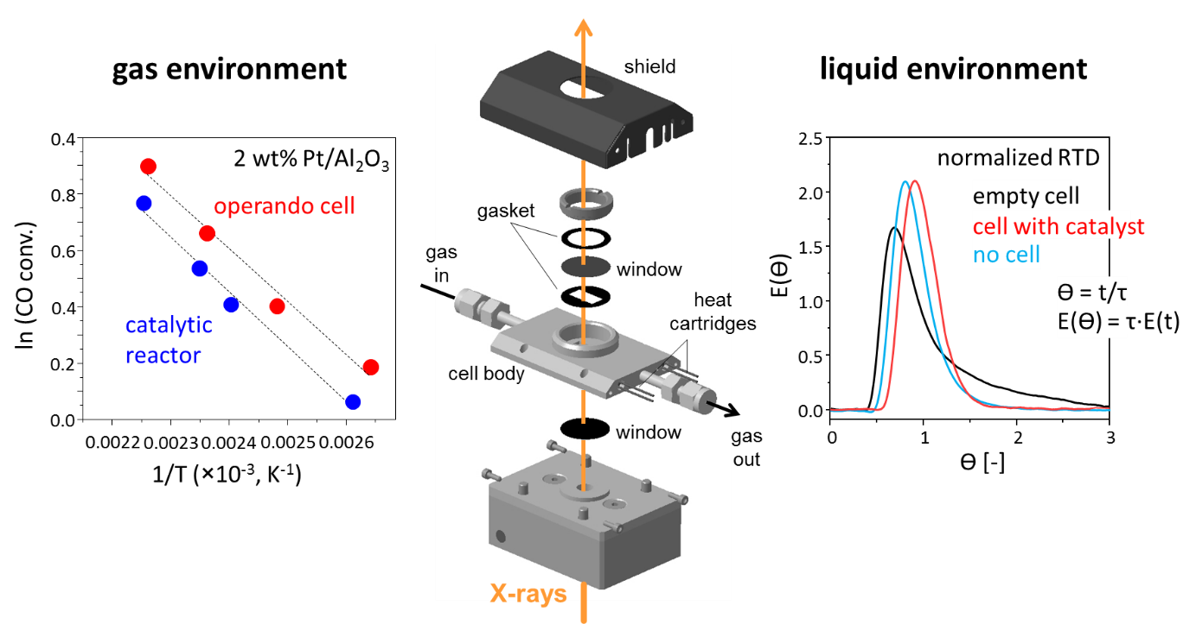
Figure 1. Scheme of the operando cell and cell characterization (left) using CO oxidation as a test reaction in the gas phase and (right) of normalized residence time distribution in liquid phase.

References
[1] G.L. Chiarello, M. Nachtegaal, L. Quaroni, V. Marchionni, D. Ferri, Rev. Sci. Instrum. 2014, 85, 074102.
[2] V. Marchionni, A. Kambolis, M. Nachtegaal, O. Kröcher, D Ferri, Catal. Struct. React. 2017, 3, 71.
[3] V. Marchionni, J. Szlachetko, M. Nachtegaal, A. Kambolis, O. Kröcher, D. Ferri, PCCP 2016, 18, 29268.

